**MP 4.2 Part 1: Q-Learning (Pong)**

**Main Result**

Best result was found when $γ=0.7, ϵ=0.05, C=50 or α=\frac{50}{50+N\left(s,a\right)}$

After training the agent on 100,000 training games:

$$\left(Average bounce in a game, for 1000 test games\right)=6.84$$

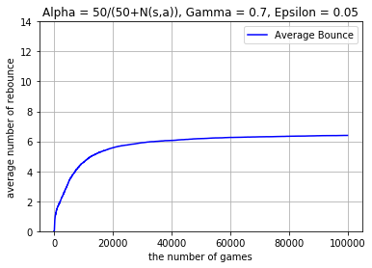

**Discretization of continuous state**

A state of the pong game can defined by:

$$Continuous state=(ball_{x},ball_{y}, V_{x}, V_{y}, Paddle_{y})$$

Where:

$$ball_{x}∈Real\left(0,1\right)$$

$$ball_{y}∈Real\left(0,1\right)$$

$$V_{x}∈Real\left(-∞, -0.3\right)∪Real\left(0.3, ∞\right)$$

$$V_{y}∈Real\left(-∞, ∞\right)$$

$$Paddle_{y}∈Real\left(0, 0.8\right)$$

However, we can’t use Q-learning algorithm on a continuous state – there are infinitely many states. So, we discretize the states:

Conversion: Continuous State 🡪 Discrete State

$$Discrete State=\left(ball_{xdisc}, ball_{ydisc}, V_{xdisc}, V_{ydisc}, Paddle_{ydisc} \right)$$

$$ball_{xdisc}=\left\lfloor 12 *ball_{x}\right\rfloor$$

$$ball_{ydisc}=\left\lfloor 12 *ball_{y}\right\rfloor$$

$$V_{xdisc}=sign( V_{x} )$$

$$V_{ydisc}=\left\{\begin{aligned}sign\left(V_{y}\right) if \left|V_{y}\right|<({0.2=V}_{ythreshold}) \\ 0 otherwise\end{aligned}\right.$$

$$Paddle_{ydisc}= \left\lfloor 12*\frac{Paddle_{y}}{0.8}\right\rfloor$$

Note: We chose to make $V_{ydisc}=0$ if $V_{y}<0.2$ since it is a reasonably negligible speed.

The number of all possible discrete states is 12*12*2*3*12 +1 =10369.

$$Discrete State∈\left(ball_{xdisc}, ball_{ydisc}, V_{xdisc}, V_{ydisc}, Paddle_{ydisc} \right) ∪\{game over\}$$

$$ball_{xdisc}∈\left\{0,1,2,.., 11\right\}$$

$$ball_{ydisc}∈\left\{0,1,2,.., 11\right\}$$

$$V_{xdisc}∈\left\{-1, 1\right\}$$

$$V_{ydisc}∈\left\{-1,0,1\right\}$$

$$Paddle_{ydisc}∈\left\{0,1,2,..,11\right\}$$

We found that for larger number of discrete states, a larger number of training game is required to converge to a good policy.

(Number of all Q-values) = 10368*3 = 31104, since there are 3 possible actions for each state.

**Exploration function**

$$Expoloration policy \left( discrete state_{i}\right)= \left\{\begin{aligned}argmax_{{action}^{'}}\left( Q\left(discrete state_{i}, action'\right)\right) for \left(1-ϵ\right)100\% of the time \\ random ( \left\{move up, move down, don^{'}t move\right\} ) for \left(1-ϵ\right)100\% of the time\end{aligned}\right.$$

We chose $ϵ=0.05$ for good result (justification is discussed later.)

**Choosing an optimal discount rate, $γ$:**

We chose $α=0.7$

Justification:

Suppose, in $state_{a}$ and $state_{b}$, the ball is bounced. We don’t want $state_{a}$ to affect calculation of $state_{b}$’s Q value. Assuming that on average, $State_{a}$ and $State_{b}$ are separated by 24 steps, the discount factor for $state_{a}$ is $γ^{24}$.

|  |  |
| --- | --- |
| $$γ$$ | $$γ^{24}$$ |
| 0.9 | 0.0798 = 7.98% |
| 0.8 | 0.00472=0.472% |
| 0.7 | 0.0019 = 0.02% just small enough |
| 0.6 | 0.0000047= too small |

**Choosing an optimal learning rate, $α=\frac{C}{C+N\left(s,a\right)}$:**

Using epsilon = 0.05, gamma=0.7, we manually check C values {15, 50, 100, 500}.

We find that learning rate converges quickest when **C=50**.

|  |  |
| --- | --- |
| C | number of training game to reach bounce average of 6 |
| 15 | 32108 |
| 50 | 19106 |
| 100 | 35872 |
| 500 | 62311 |
|  |  |

**Choosing an optimal epsilon, $ϵ:$**

Using gamma = 0.7, C=50, and 10,000 training games, we analyze epsilon values {0.01, 0.05, 0.15, 0.3}. We find that **epsilon= 0.05** gives highest average number of bounces.

In the below plots, the average number of bounces is updated after each training game. (The old average is updated to new average.)

Epsilon =0.01

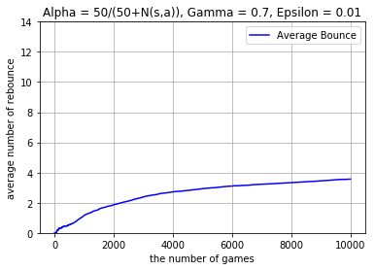

Epsilon=0.05

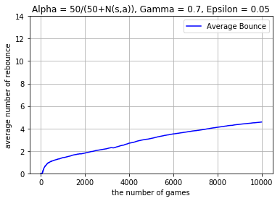

Epsilon= 0.15

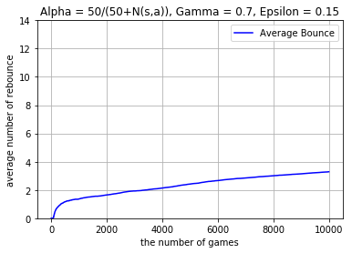

Epsilon=0.3

